MACHINE LEARNING
ASSIGNMENT-2
NAME : Sai Leela Otikundala
STUDENT ID : 700747149
EMAIL ID : sxo71490@gmail.com

Question1 :
Use a python code to display the following star pattern using the for loop
*
* *
* * *
* * * *
* * * * *
* * * *
* * *
* *
*
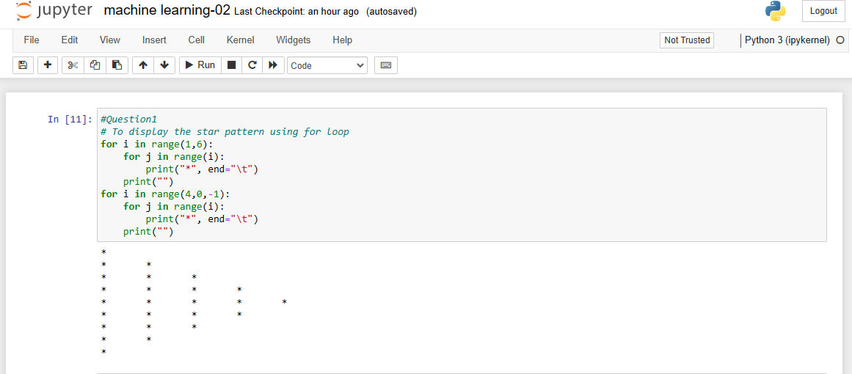
- By using for loop,printed the following star pattern

Question2 :
Use looping to output the elements from a provided list present at odd indexes. my_list = [10, 20, 30, 40, 50, 60, 70, 80, 90, 100]
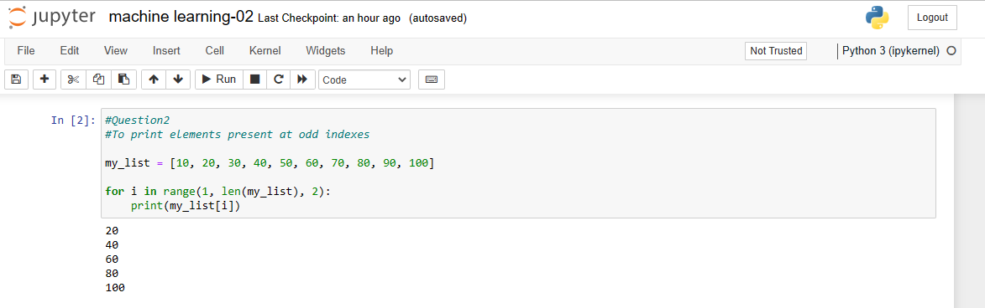

- Printed the elements present at the odd indexes.

Question3:
Write a code that appends the type of elements from a given list.
Input
x = [23, ‘Python’, 23.98]
Expected output
[23, 'Python', 23.98]
[<class ‘int’>, <class ‘str’> , <class ‘float’> ]

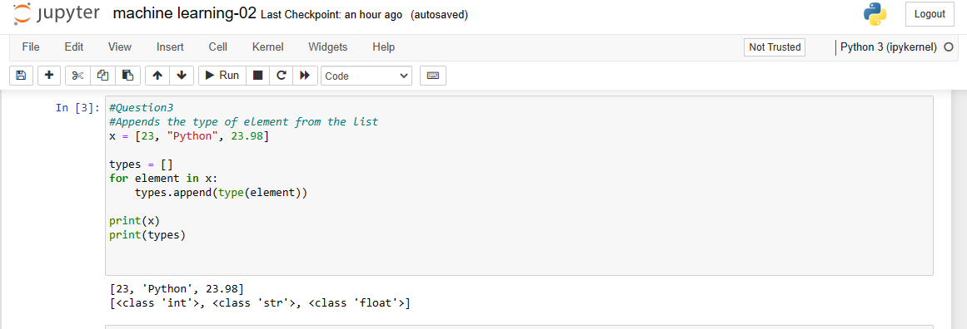

- Appends the type of elements from the given list

Question4:
Write a function that takes a list and returns a new list with unique items of the first list.
Sample List: [1,2,3,3,3,3,4,5]
Unique List: [1, 2, 3, 4, 5]

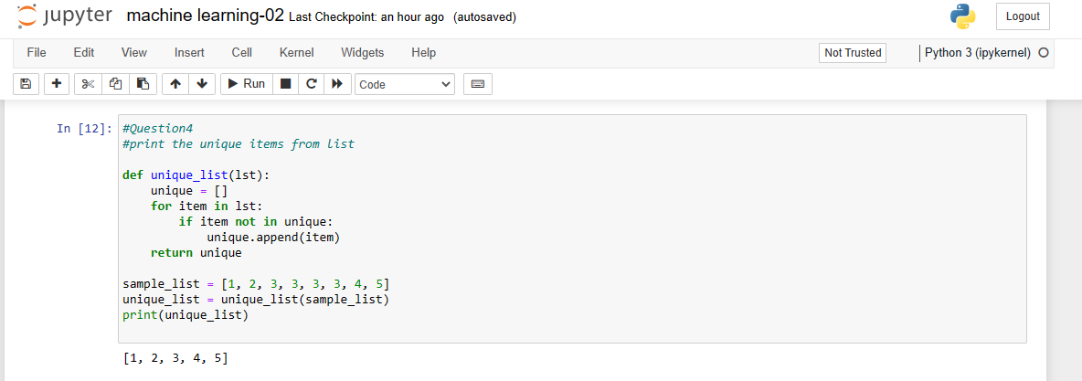

- Returns only unique list of items from the list

Question5:
Write a function that accepts a string and calculate the number of upper-case letters and lower-case letters.
Input String: 'The quick Brow Fox'
Expected Output:
No. of Upper-case characters: 3
No. of Lower-case Characters: 12

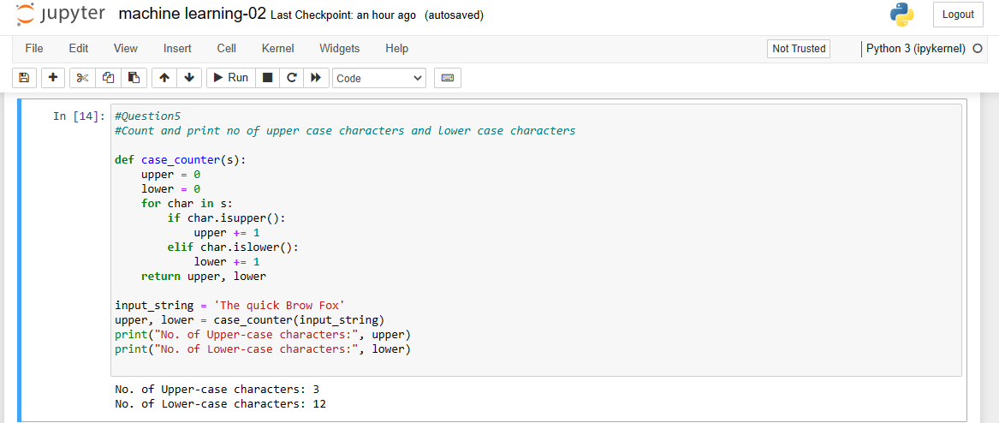

- Prints number of upper case characters and lower case characters of the string.

